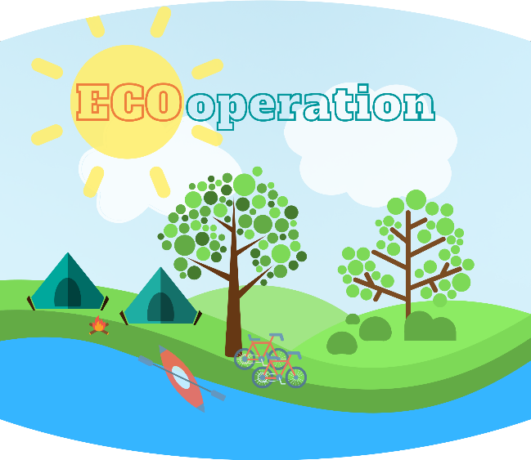

Project title: ECOoperation - Cross-border cooperation of secondary schools in developing common tools in
practical training of natural sciences (water, soil, micro-climate)

Project value: 241.870,93 €
EU contribution: 205.590,27 €
Project duration: 01.07.2020. – 31.12.2021.
Lead Beneficiary: Csokonai Vitéz Mihály Református Gimnázium, Általános Iskola és Kollégium
Partners: Gimnazija „Fran Galović”, Srednja škola Prelog

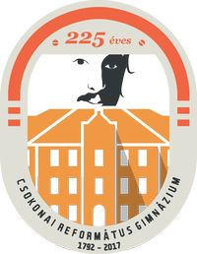

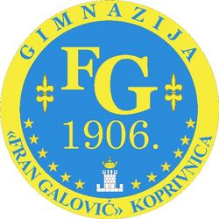

This poster has been produced with the financial assistance of the European Union. The content of the poster is the sole responsibility of Fran Galović Gymnasium and can under no circumstances be regarded as reflecting the position of the European Union and/or the Managing Authority.

